A 3: Capture the packets from wireshark by performing some work.

Step 1: Open google and search anything.

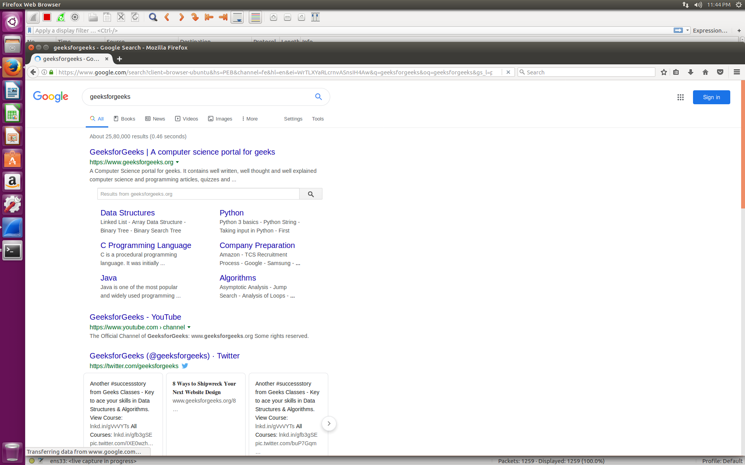

Step 2: Capture the packets.

